**Nama : Eko Susanto**

**Nrp : 2110147055**

**Kelas : 1 D4 LJ PJJ**

**[Buatlah program untuk UML dalam soal pada attachment. Kerjakan tugas yang ada di dalamnya. Kumpulkan source code yang anda buat. (Hanya source code)]**

|  |
| --- |
| **package testcontainer;**  **/\*\***  **\***  **\* @author CE-302**  **\*/**  **public class Container {**  **public int volume;**  **public int maxVolume;**    **public void empty(){**  **this.volume=0;**  **}**  **public void fill(Container con){**  **//container bisa diisi**  **if(this.volume < this.maxVolume){**  **//container pemasok masih punya air**  **if(con.volume > (this.maxVolume - this.volume)){**  **con.volume -= (this.maxVolume - this.volume);**  **this.volume = this.maxVolume;**  **}**  **else{**  **this.volume = con.volume;**  **con.volume -= con.volume;**  **}**  **}**  **}**  **}** |

|  |
| --- |
| **package testcontainer;**  **/\*\***  **\***  **\* @author CE-302**  **\*/**  **public class Sumur extends Container{**  **public int volume;**  **public int maxVolume;**    **public Sumur(){**  **super.volume = Integer.MAX_VALUE;**  **super.maxVolume = Integer.MAX_VALUE;**  **}**    **@Override**  **public void fill(Container con) {**  **super.fill(con); //To change body of generated methods, choose Tools | Templates.**  **}**  **@Override**  **public void empty() {**  **super.empty(); //To change body of generated methods, choose Tools | Templates.**  **}**    **}** |

|  |
| --- |
| **package testcontainer;**  **/\*\***  **\***  **\* @author CE-302**  **\*/**  **public class Glass extends Container{**  **public int volume;**  **public int maxVolume;**    **/*public Glass (){**  **super.volume = 0;**  **super.maxVolume = 0;**  **}*/**    **public Glass(int volume, int maxVolume) {**  **super.volume = volume;**  **super.maxVolume = maxVolume;**  **}**  **}** |

|  |
| --- |
| **package testcontainer;**  **/\*\***  **\***  **\* @author CE-302**  **\*/**  **public class Testcontainer {**  **/\*\***  **\* @param args the command line arguments**  **\*/**  **public static void main(String[] args) {**  **// TODO code application logic here**  **Container sumber = new Sumur();**  **Container small = new Glass(0, 1);**  **Container med = new Glass(0, 5);**  **Container big = new Glass(0, 10);**    **med.fill(sumber);**  **small.fill(med);**  **big.fill(med);**    **/*System.out.println("small = " + small.volume + ", " + small.maxVolume );**  **System.out.println("med = " + med.volume + ", " + med.maxVolume );**  **System.out.println("big = " + big.volume + ", " + big.maxVolume );*/**    **System.out.println("Gelas medium diisi dengan 4L air");**    **med.fill(sumber);**  **System.out.println("Sumber mengisi gelas medium " +med.volume+ "L");**    **small.fill(med);**  **System.out.println("Gelas medium mengisi gelas small " +small.volume+ "L");**    **big.fill(med);**  **System.out.println("Gelas medium mengisi gelas big " +big.volume+ "L");**    **med.fill(big);**  **System.out.println("Gelas big mengisi gelas medium " +med.volume+ "L");**    **System.out.println("=================================================");**    **System.out.println("Gelas big diisi dengan 6L air");**    **big.fill(med);**  **System.out.println("Gelas medium mengisi gelas big " +big.volume+ "L");**    **big.fill(small);**  **System.out.println("Gelas small mengisi gelas small " +big.volume+ "L");**    **small.fill(sumber);**  **System.out.println("Sumber mengisi gelas small big " +small.volume+ "L");**    **big.fill(small);**  **System.out.println("Gelas small mengisi gelas big " +big.volume+ "L");**  **}**    **}** |

Hasil :

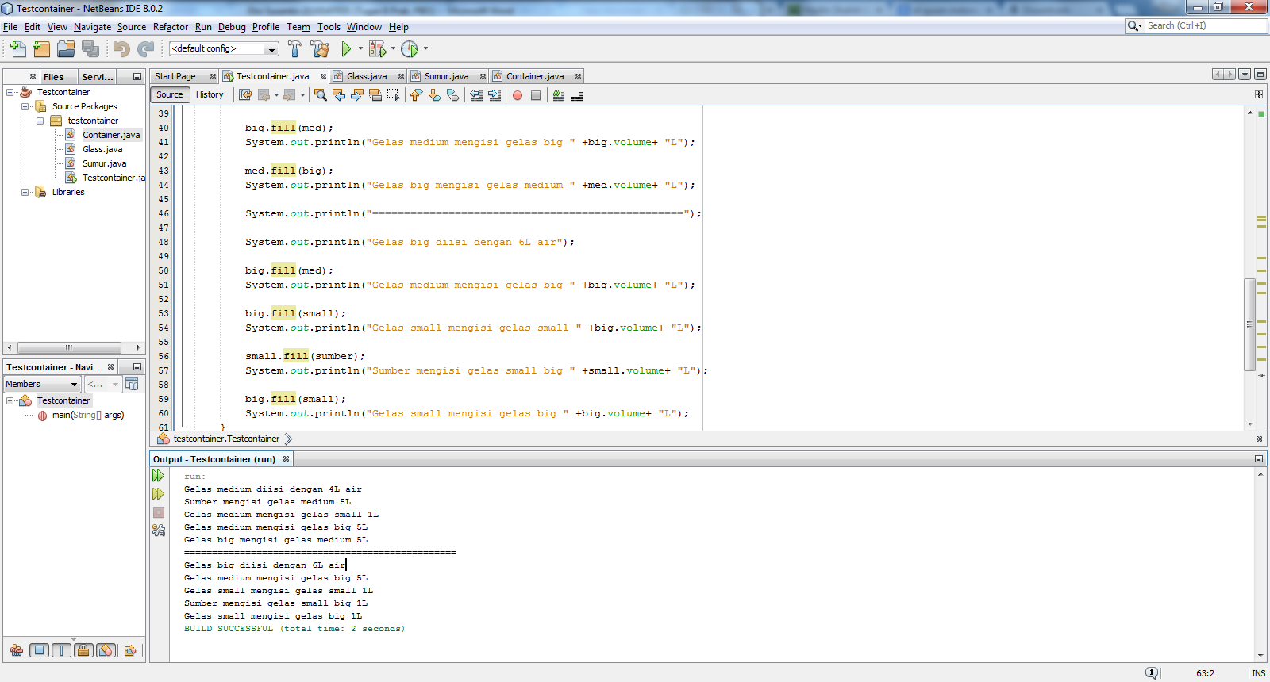

NB : Maaf Pak,hasilnya masih salah